Physics 30 Lesson 23 Electromagnetism Activities

## Station 1 Conductors in magnetic fields (the motor effect)

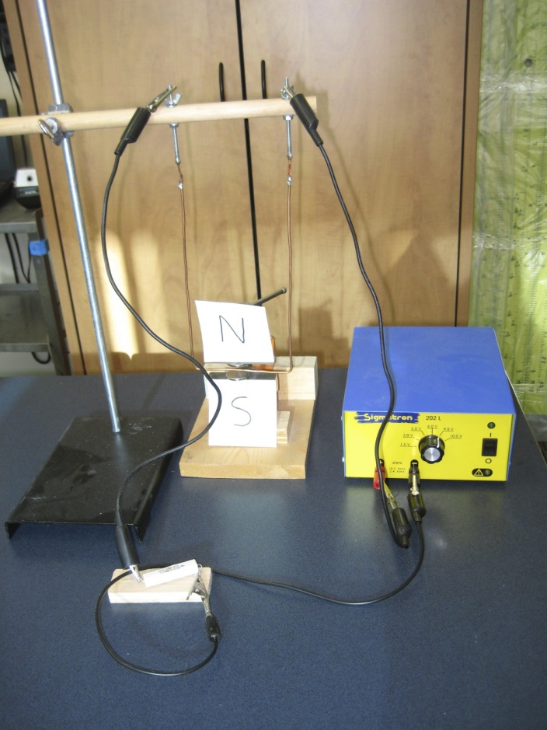In this apparatus, you will find a retort stand with a copper wire hanging between two magnets. A power supply with a current-limiting-resistor is attached to the top of the apparatus. *Turn the power on for brief instances only*.

Procedure:

1 . Before turning the power on – using the appropriate hand rule, predict the direction that the hanging wire will move.

hanging copper wire

2. Turn the power on and note what happens to the wire.

neodymium magnets

3. Reverse the power supply wires at the power supply and repeat #1 and #2.

Questions

* What was the effect of the current running through the wire? Relate what you saw to the open palm hand rule.
* Explain what you observed in terms of the motor effect.

## Station 2 Solenoids – induced current

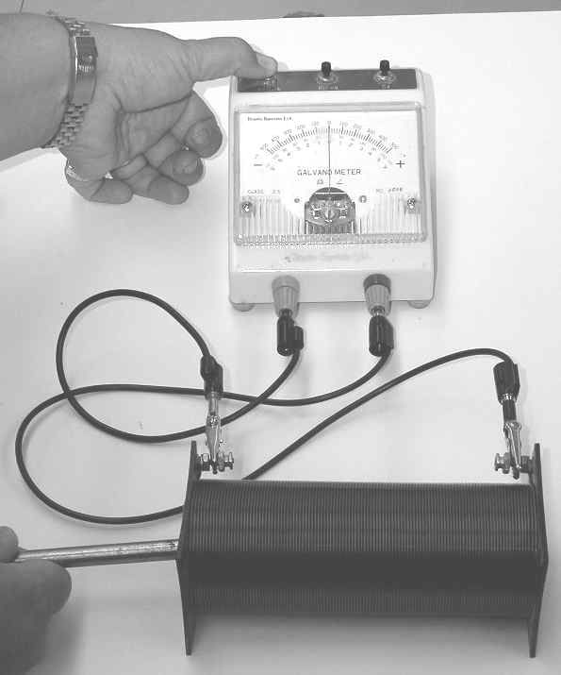

Press down on the far left button of the galvanometer.

In this apparatus, a solenoid is hooked up to a galvanometer. You will also find a neodymium magnet attached to a steel nail on the table. Note: For this station you are not trying to work with the hand rule. Rather you are working with the general principle of induction.

Procedure:

1. Push the magnet into the solenoid core, pause, and then pull it out again. Notice how the galvanometer responds.

2. At the other end of the solenoid, repeat #1.

Questions:

1. What does a *galvanometer* measure or indicate?
2. What was the effect of pushing the magnet into the solenoid and then pulling it out?
3. In terms of Faraday’s law of induction, explain your observations.

## Station 3 Electric generator

At this station you will find a hand-crank generator connected to a small light bulb. **Please do not crank the generator too fast as it will cause the light bulb to burn out**.

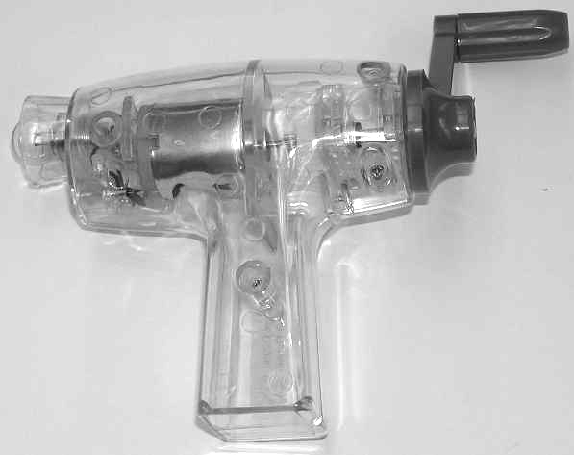

Procedure:

1. Turn the crank of the generator. Notice the result. Note the difficulty in turning the crank.

2. Unscrew the light bulb from the generator. Turn the crank and notice the result. Note the difficulty in turning the crank.

Observations:

Questions:

1. Starting with the chemical potential energy in your body, what are the energy transformations involved to produce light energy with the generator?

* Explain why the resistance on the crank was so different for when the generator did and did not have a light bulb. (It may be wise to consult with your kind and benevolent teacher to see if your explanation is accurate.)

## Station 4 Swinging aluminum paddles

In this apparatus, there are two aluminum “paddles” that can swing between the magnetic field produced by two powerful magnets. One aluminum paddle is solid while the other is like a comb with multiple prongs. (Special thanks go to Ryan Gibson for fabricating the paddles.)

Procedure:

1. Using the comb paddle first, lift the paddle to one side of the magnetic field and ten let it swing through the field.

2. Replace the comb paddle with the solid paddle. Draw the paddle to one side and allow it to swing through the magnetic field.

Observations:

Questions:

1. Is aluminum metal ferromagnetic ?
2. Using Faraday’s law of induction and Lenz’s law, explain how the paddles were affected by the magnetic field?

1. Why was the *comb* paddle not as affected by the magnetic field while the *solid* paddle was greatly effected? (It may be wise to consult with your kind and benevolent teacher to see if your explanation is accurate.)

**Station 5 The vertical tubes**

In this apparatus, you will find a long hollow copper tube and a long hollow plastic tube. In addition you will find two aluminum cylinders.

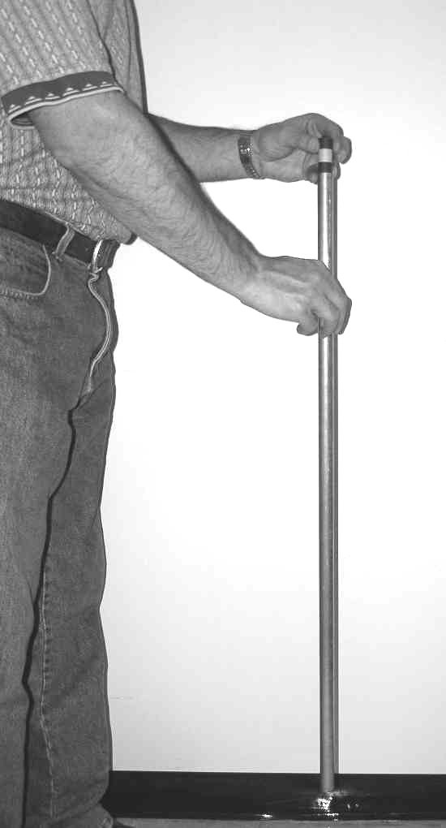

Procedure:

1. Place the plain aluminum cylinder in the top of the plastic tube and let it fall through the tube. Note what happens.

2. Place the aluminum cylinder with the magnet glued in the middle in the top of the plastic tube and let it fall through the tube. Note what happens. (Note: **The magnet is glued between the aluminum pieces and it is very fragile. Care should be taken in using this apparatus**.)

3. Replace the plastic tube with the copper tube. Repeat steps 1 and 2 for the copper tube.

Observations:

Questions:

1. In terms of Faraday’s law of induction, Lenz’s law and the resulting forces, explain what you observed. (It may be wise to consult with your kind and benevolent teacher to see if your explanation is accurate.)